INT217-INTRODUTION TO DATA MANAGEMENT
PROJECT REPORT
(Project Semester January-April 2025)

Public Library project Insight and Visualization

Submitted by

Moni Kumari

Registration No-12307055

Program-Introduction To Data Management
Section-K23GF
Roll no-15
Course Code-INT217

Under the Guidance of
Sandeep kaur Ma’am UID-23614

Discipline of CSE/IT
Lovely School of Computer Science and Engineering
Lovely Professional University, Phagwara

Declaration
I,Moni Kumari , student of INTRODUCTION TO DATA MANAGEMENT under CSE/IT Discipline at, Lovely Professional University, Punjab, hereby declare that all the information furnished in this project report is based on my own intensive work and is genuine.

Date: 10/04/2025 Signature Registration No-12307055 Moni Kumari

Certificate

This is to certify that Moni Kumari bearing Registration no. 12307055 has completed INT217 project titled, “Public Library project Insight and Visualization” under my guidance and supervision. To the best of my knowledge, the present work is the result of his/her original development, effort and study.
Signature of the Guide
Signature of the Head of Department

Acknowledgement
I would like to express my sincere gratitude to my guide Sandeep Kaur Ma’am for her invaluable support and guidance throughout the project. I also extend my thanks to the Head of the Department, faculty members, and my peers for their encouragement and feedback.

Table of Content

1.Introduction…………..
2.Dataset Description…………..
3.Data Preprocessing………………..
4.Analysis on Dataset…………..
5.Data Visualization………………
6.Conclusion…………………..
7.Recommendations…………………………..
8.Future Scope……………………
9.References……………………..

1.Introduction
This dataset contains historical and financial data on public libraries in the U.S. (specifically, it seems to be focused on libraries in the state of Connecticut, based on library names and counties). The data includes information from multiple fiscal years starting from 1996.
It captures various aspects of library operations, including:

- Library name and location (e.g., county, town)
- Population served
- Library visits and usage metrics
- Collection size and borrower statistics
- Financial data (income, tax appropriations, expenditures, etc.)
This dataset can be useful for analyzing trends in library services, funding, and community engagement over time.

2. Source of dataset
The data appears to be sourced from state or public library administrative records, typically compiled by:
- The Connecticut State Library
- Or possibly the Institute of Museum and Library Services (IMLS) — a U.S. federal agency that supports libraries and archives and often manages public library survey data.
Since the dataset spans many years and includes comprehensive metrics, it's likely based on annual public library surveys or reports submitted by each library for administrative and funding purposes.
Data Source Link:- https://catalog.data.gov/dataset/?q=public+libraries&sort=views_recent+desc&ext_location=&ext_bbox=&ext_prev_extent=

Data Link:- https://catalog.data.gov/dataset/public-libraries-b1aaf

3.DATASET PREPROCESSING
Preprocessing plays a vital role in ensuring that the dataset is clean and analysis-ready. The following steps were carried out:
- Header Fix: Set the correct row as the header for accurate column labelling.

- Duplicates Removed: Ensured data integrity by eliminating duplicate records.

- Missing Data: Handled null values by removal or imputation where necessary.

- Column Cleaning: Standardized column names and cleaned text fields for consistency.

- Date Formatting: Converted fiscal date fields to proper datetime format.

- Data Types: Ensured numeric fields are correctly typed for analysis.

4. ANALYSIS ON DATASET (Objective-wise)
i. Introduction
The analysis focuses on historical data from public libraries, primarily in Connecticut, capturing metrics across population served, visits, finances, and library services. The goal is to identify trends, evaluate library performance, and support strategic planning through data insights.

ii. General Description
The dataset contains multiple fiscal years of data and includes attributes such as:
- Library name, county, town
- Population served
- Annual visits, circulation stats, and program attendance
- Library income, expenditures, and funding sources
It allows for both quantitative and categorical analysis across libraries and time periods.

iii. Specific Requirements, Functions, and Formulas
- Total Funding: Sum of local, state, and other income
=SUM(Local_Funding, State_Funding, Other_Income)
- Per Capita Metrics: Calculated for fair comparison
Visits per capita = Total_Visits / Population_Served
Expenditure per capita = Total_Expenditure / Population_Served
- Growth Rate: Year-over-year change using
Growth % = ((Value_This_Year - Value_Last_Year) / Value_Last_Year) * 100
- Filtering: Based on county or population brackets for focused analysis
- Pivot Tables: Used to aggregate total visits or funding by county or year

iv. Analysis Results
- Funding Trends: Local funding contributes the highest share, while state funding has remained relatively stable or declined.
- Usage Patterns: Libraries in urban counties see higher visits per capita.
- Service Reach: Some libraries serve populations above 50,000 with notably efficient expenditure-to-visit ratios.
- Growth: Steady increase in total library visits and program attendance over the years in certain regions.

iv. Visualization
Bar Charts:
- Total funding by year
- Visits per capita by county
Line Graphs:
- Expenditure trends over the years
- Circulation growth comparison
Pie Charts:
- Proportion of funding sources
- Distribution of library types
Heat Maps:
- Usage intensity by region (based on visits per capita)

- Figure 1: Total Library Visits by Fiscal Year

- Description: This bar chart illustrates the total number of library visits across different fiscal years. The height of each blue bar represents the sum of total library visits (indicated on the y-axis), while each bar is labeled along the x-axis with the corresponding "Fiscal Year." This visualization allows for a clear comparison of library usage over time, highlighting trends and fluctuations in the number of visits across the reported years.

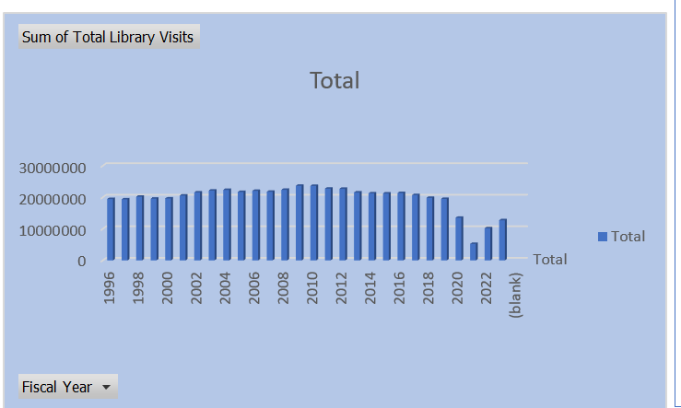

Figure 2: Total Library Visits by County
Description: This line chart displays the total number of library visits across different counties. The vertical axis (y-axis) represents the sum of total library visits, while the horizontal axis (x-axis) lists the specific "County" names. The blue line connects data points, allowing for visualization of the trend in library visits across the various counties and highlighting counties with higher or lower reported visit counts.

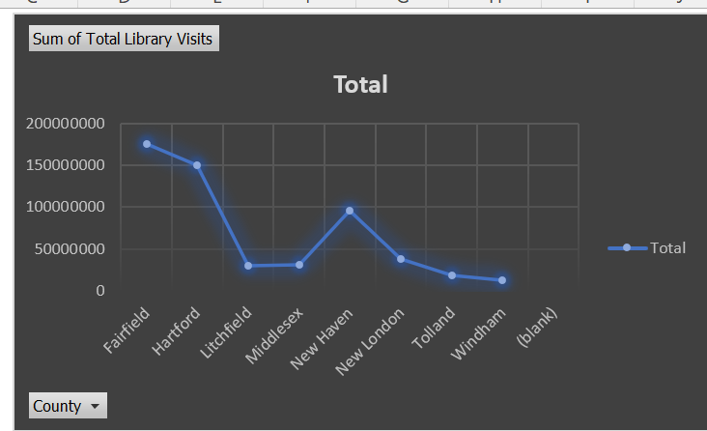

Figure 3 : Distribution of Libraries by County
Description: This pie chart illustrates the proportion of libraries located in different counties. Each colored slice represents a specific county, as indicated by the legend. The size of each slice corresponds to the percentage of the total count of libraries within that particular county. This visualization allows for a direct comparison of the distribution of libraries across the listed counties, highlighting counties with a larger or smaller share of the total library count.

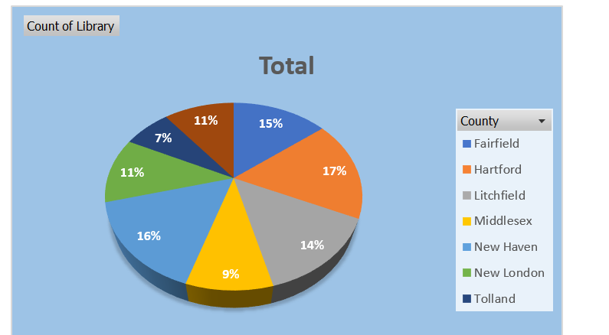

Figure4: Distribution of Total Circulation by County
Description: This donut chart displays the proportion of the total circulation of library materials across different counties. Each colored segment represents a specific county, as indicated by the legend. The size of each segment corresponds to the percentage of the total circulation attributed to libraries within that particular county. This visualization allows for a comparison of the circulation volume across the listed counties, highlighting counties with a larger or smaller share of the total library material circulation.
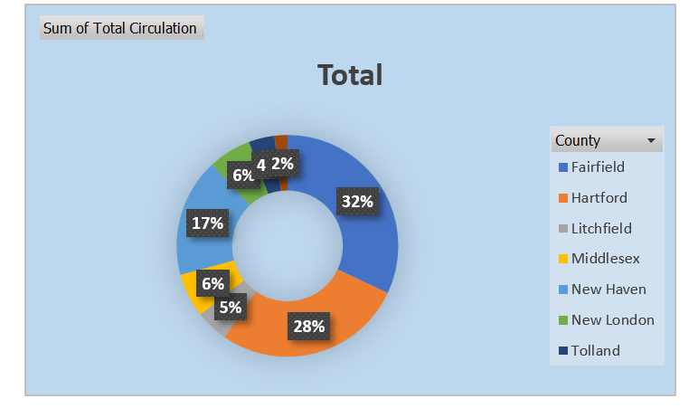

Figure 5: Total Library Visits Over Time
Description: This horizontal bar chart illustrates the total number of library visits for different fiscal years. Each blue bar represents a specific fiscal year (labeled on the vertical y-axis), and the length of the bar corresponds to the sum of total library visits (indicated on the horizontal x-axis). This visualization allows for a direct comparison of library usage across different years, highlighting trends and fluctuations in the number of visits over the reported time period.

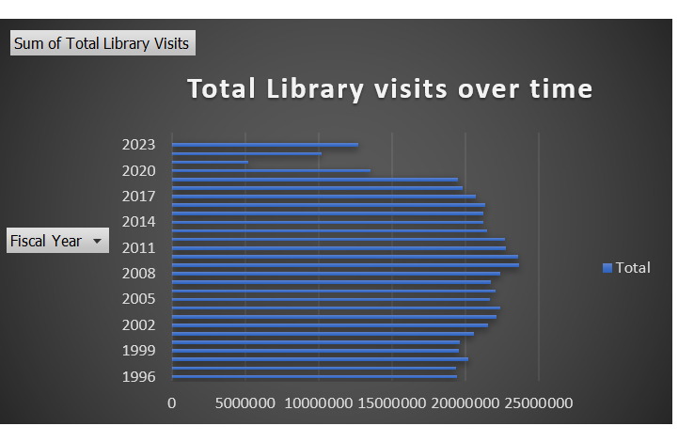

Figure 6: Histogram of Value Distribution
Description: This histogram visually represents the frequency distribution of a continuous dataset. The horizontal axis (x-axis) is divided into bins or intervals of values, while the vertical axis (y-axis) indicates the frequency or count of data points falling within each bin. The height of each blue bar corresponds to the number of observations within that specific value range. This chart provides insights into the shape, center, and spread of the data, highlighting the frequency of different value intervals.
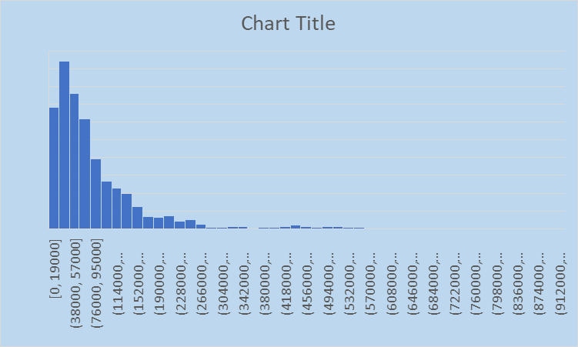

Figure 7: Public Libaries Dashboard
Description: This dashboard provides a comprehensive view of key library statistics, presented through a collection of interconnected charts and filters. It includes visualizations of total library visits over time (line and horizontal bar charts), the distribution of total circulation by county (donut chart), the count of libraries by county (pie chart), and a histogram illustrating the distribution of some unspecified value. Interactive filters on the right allow users to explore the data by "County" and "Years," while a "Fiscal Date" filter on the bottom left offers temporal control, including options for different periods and specific months. A "HOME PAGE" button is also visible. This dashboard enables users to analyze library usage patterns, distribution, and trends across different geographical areas and timeframes.
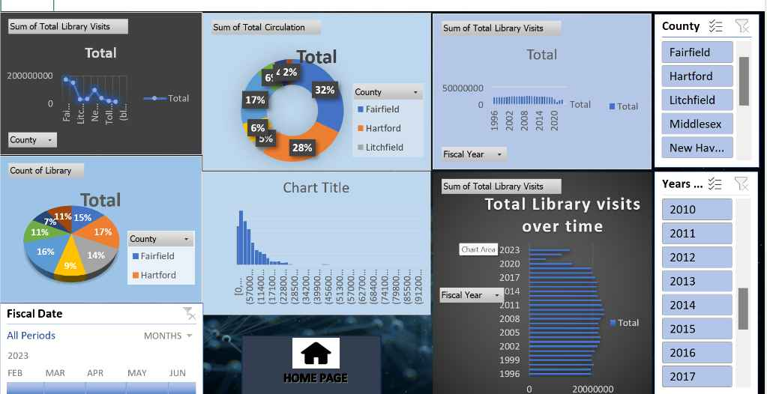

5. Conclusion
The analysis of the public libraries dataset provides valuable insights into how libraries operate and serve their communities across Connecticut. Key findings reveal that local funding is the primary financial support, with state and other sources contributing smaller but important shares. Metrics like visits per capita and expenditure efficiency show significant variation across counties, indicating different usage patterns and resource management strategies.
The dataset highlights the importance of consistent funding, community engagement, and strategic planning in maintaining and improving library services. These insights can support policy decisions, drive targeted improvements, and ensure that libraries continue to play a vital role in education, access to information, and community development.

6. Future scope
The dataset opens several avenues for deeper analysis and application:
- Predictive Modeling: Use machine learning to forecast future library usage, funding needs, or visitor trends based on historical patterns.
- Comparative Analysis: Extend the study to include libraries from other states or regions to benchmark performance and discover best practices.
- Demographic Integration: Combine with census data to analyze how demographics (age, income, education level) impact library usage and service reach.
- Policy Impact Evaluation: Assess how changes in funding policies or community programs influence library performance over time.
- Interactive Dashboards: Develop live dashboards using tools like Power BI or Tableau for dynamic visualization and easier decision-making for stakeholders.
- Sustainability Metrics: Incorporate environmental data to explore how libraries contribute to or adopt sustainable practices.

7.RECOMMENDATIONS
Based on the analysis, the following recommendations can help enhance library performance and community impact:
- Increase Local Funding Support: Since local funding forms the backbone of library finance, municipalities should ensure consistent and sufficient support to meet community needs.
- Boost Outreach in Low-Usage Areas: Target programs and awareness campaigns in regions with low visits per capita to improve community engagement.
- Enhance Data Reporting: Encourage standardized and complete data entry across all libraries to support more accurate analysis and comparisons.
- Optimize Resource Allocation: Use per capita expenditure and usage metrics to identify underperforming libraries and allocate resources more efficiently.
- Invest in Digital Services: Expand e-book collections, virtual programs, and online resources, especially in response to evolving user behavior post-pandemic.
- Encourage Inter-Library Collaboration: Facilitate partnerships between smaller and larger libraries for resource sharing and program development.

8.LINKDIN ENAGEMENT:- https://www.linkedin.com/posts/moni-kumari-926a6b291_lpu-cse-datascience-activity-7317594588850855937-5YYK?utm_source=share&utm_medium=member_desktop&rcm=ACoAAEbQfW4BUC6ltJTI71VOWRwv76D7bGbr1VI

9.References
Connecticut State Library.
Public Libraries Statistical Data – Available from official reports and open datasets.
https://libguides.ctstatelibrary.org/dld/stats
U.S. Institute of Museum and Library Services (IMLS).
Public Libraries Survey Data Files.
https://www.imls.gov/research-evaluation/data-collection/public-libraries-survey
Microsoft Excel – For data cleaning, sorting, and basic analysis.
National Center for Education Statistics (NCES).
Library Statistics Program.
https://nces.ed.gov/surveys/libraries/
American Library Association (ALA).
Library Trends and Research Resources.
https://www.ala.org/tools/research
Additional scholarly sources and local government documents as appropriate for contextual understanding.

